|  |  |  |
| --- | --- | --- |
| **Health Support Plan: Mealtime Management or Dysphagia Support** | | |
| **Participant name:** | |  |
| **Occupational therapist /speech pathologist name:** | |  |
| **Date of assessment:** | |  |
| **Annual (recommended) review date:** | |  |
| **Upon review have changes been made to this plan?** | | Yes No |
| **Occupational therapist /speech pathologist signature:** | |  |
| **Particpant supported with ( tick one):**  **□** Mealtime management only (not dysphagia)  **□** Mealtime management with dysphagia support | | |
| **Mealtime management plan is developed by the speech pathologist –** follow the specific plan for the participant | | |
| **Supervision:** |  | |
| **Assistance:** |  | |
| **Diet:**  IDDSI level: |  | |
| **Fluids:**  IDDSI level: |  | |
| **Allergies:** |  | |
| **Likes & Dislikes:** |  | |
|  | | |
| Choking First Aid – Top 16 Do's & Don'ts | St John VicHow I like to be supported:   * monitor me while I eat * have access to a working phone in case of an emergency * provide first aid in the event of choking * other ……   Follow the speech pathologist’s health support plan   * Choose appropriate food textures - Follow the IDDSI Framework * Follow food safety procedures * Avoid distractions during mealtimes * Discourage talking whilst eating and drinking * Do not force the person to eat or drink * Offer small bites and sips * Allow the participant to take their time * Respect the participants dignity and independence | | |
| **Emergency actions:** | | |
| **If required, while I am having a choking episode, please contact Emergency services on 000 or present to the nearest hospital.**  **In an emergency, please contact:** | | |

Participant / Nominee Signature: Date:

**IDDSI International Dysphagia Diet Standardisation Initiative 2019**

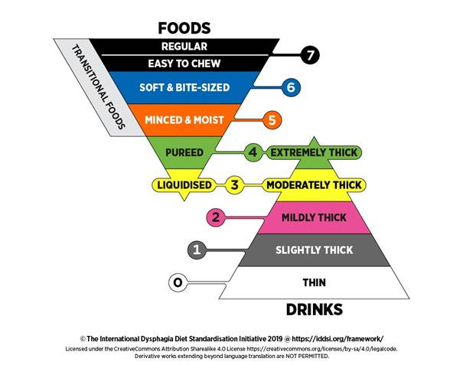

|  |  |
| --- | --- |
| drink | yes |
| food | more |
|  | finish |
| stop | no |

**PARTICIPANT NAME**:

**PLAN DATE**:

# **Staff acknowledgement**

I have read and understood the Meal Management Plan for this participant.

|  |  |  |  |
| --- | --- | --- | --- |
| **#** | **Worker Name** | **Worker Signature** | **Date** |
|  |  |  |  |
|  |  |  |  |
|  |  |  |  |
|  |  |  |  |
|  |  |  |  |
|  |  |  |  |
|  |  |  |  |
|  |  |  |  |
|  |  |  |  |
|  |  |  |  |
|  |  |  |  |
|  |  |  |  |
|  |  |  |  |
|  |  |  |  |
|  |  |  |  |
|  |  |  |  |
|  |  |  |  |
|  |  |  |  |